
Table of Contents
1. Data Quality Checks 3
1.1 Duplicate products or shipments 3
1.2 SKUs in sales that don’t exist in dim_product 3
1.3 Shipment referential integrity is extremely weak 3
1.4 Check how many records and sales volume we have for each year-month 4
1.5 Returns > sold 4
1.6 Negative quantities 4
1.7 Gross sales validation 4
1.8 Net sales validation 4

Data Quality Checks
All the data quality checks code is inside analysis/data_quality.sql

Duplicate products or shipments
I checked for duplicate records in both dim_product and fct_shipment, and no duplicates were found. This is important because both tables define a unique key (sku for products and shipment_id for shipments).
If duplicates were present, joining fct_sale_order_line with either table could multiply rows and consequently inflate metrics such as sales, quantities, returns, or shipping costs. This would be particularly problematic because fct_sale_order_line links to products through sku and to shipments through shipment_id.

SKUs in sales that don’t exist in dim_product
I found 922 distinct SKUs in fct_sale_order_line. Of these, 722 (78.3%) do not exist in dim_product, meaning that only 200 SKUs (21.7%) can be matched to the product dimension.
The unmatched SKUs follow a clear pattern: they all start with SKU-9, while the SKUs present in dim_product start with SKU-0. This suggests that the issue is systematic rather than a small number of isolated missing products.
This creates a significant referential integrity issue. Since sku is the key linking fct_sale_order_line to dim_product, these unmatched sales cannot be reliably enriched with product attributes such as name, category, or cost.
Any analysis by product category or contribution margin using dim_product.cost would therefore be incomplete or potentially misleading unless these unmatched SKUs are handled explicitly.

Shipment_ids in sales that don’t exist in fct_shipment
I found 24,741 distinct shipment_id values in fct_sale_order_line. Of these, 499 (2.0%) do not exist in fct_shipment.
The unmatched shipment IDs follow a clear pattern: they fall within the SHP-90... to SHP-99... range, while the shipment IDs that exist in fct_shipment start with SHP-00.... This suggests the missing references are systematic rather than isolated records.
This creates a referential integrity issue because shipment_id is the key linking fct_sale_order_line to fct_shipment. As a result, the affected sales cannot be reliably enriched with shipment attributes such as shipping_method, shipping_cost, or destination country.
This is particularly relevant for the contribution margin analysis, as the shipping cost is one of the costs that needs to be incorporated into the calculation.

Check how many records and sales volume we have for each year-month
I checked the number of records and sales volume by year-month. The dataset covers May 2024 to May 2026, with no gaps in the monthly data.
The expected seasonal pattern is also visible, with clear November and December peaks in both 2024 and 2025. This is consistent with the seasonal pattern described in the case study, which highlights a Nov/Dec peak in sales.

Returns > sold
I checked for cases where quantity_returned is greater than quantity_sold, which would be logically inconsistent since a customer cannot return more units than were originally sold on the same order line.
No such cases were found. Therefore, there are no apparent inconsistencies between sold and returned quantities in the dataset, and no further investigation is required for this check.

Negative quantities
I checked both quantity_sold and quantity_returned for negative values. No negative values were found.
This confirms that the quantity fields contain only non-negative values, with no apparent data-quality issues related to negative sales or return quantities.

Gross sales validation
gross_sale is provided directly in the source data, but it can also be independently calculated as dim_product.base_price × quantity_sold.
I compared the source gross_sale against the calculated value and found no discrepancies. This confirms that the source gross sales values are consistent with the underlying product prices and quantities sold.

Net sales validation
net_sales is provided directly in the source data, but it can also be independently calculated as gross_sale − taxes.
I compared the source net_sales values against the calculated values and found no discrepancies. This confirms that the net sales values are consistent with the underlying gross sales and tax amounts.

Channel Sales
For this question, I created two queries in business_questions/channel_sales.sql.

1.1 Time Grain
Query 1A measures channel performance at a monthly grain, with one row per channel and month.
I chose monthly as the primary time grain because daily data would be too noisy for a two-year business-performance view, while quarterly data would be too coarse to identify changes in channel performance. Monthly data provides a good balance for analysing channel mix, seasonality, growth, and returns. It is also particularly relevant given that the case study explicitly highlights a November/December sales peak.

1.2 Comparing channels on a like-for-like basis
I created a new metric, realized_net_sales, to account for the impact of returns:
realized_net_sales = net_sales − estimated value of returned units
I chose net_sales as the starting point rather than gross_sale because of the different tax treatment across channels. According to the source definition, Wholesale has zero taxes, while the other channels are subject to taxes. Using gross_sale would therefore make the comparison less meaningful, as it would include taxes for some channels but not others.
However, Query 1B, which aggregates performance at the channel level, highlighted another important difference: Online has a 17.9% return rate compared with only 4.2% for Wholesale. Looking only at net_sales would therefore make Online appear stronger than it actually is after accounting for returned units.
Returns also have an impact on the overall channel mix:
Channel | Net sales mix | Realized net sales mix
Online | 57,92% | 55,58%
Wholesale | 18,02% | 20,16%
Retail | 19,14% | 19,32%
Marketplace | 4,92% | 4,94%
After accounting for returns, Online's share decreases from 57.92% to 55.58%, while Wholesale increases from 18.02% to 20.16%. This is a small but meaningful redistribution of the channel mix and results in Wholesale surpassing Retail in realized net sales.

1.3 Is one channel quietly growing while another leaks?
To investigate this, I created a monthly realized_net_sales chart by channel, available in Dashboard.xlsx.
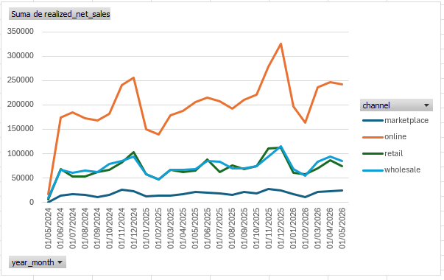
The chart does not suggest that one channel is quietly growing while another is consistently declining. Instead, the four channels broadly follow the same overall pattern, with peaks and dips occurring around similar months.
The main difference is the scale and volatility of the channels. Online, being the largest channel, naturally shows the largest absolute fluctuations, while Marketplace, the smallest channel, shows smaller movements. However, there is no clear evidence from the overall trend of a channel structurally growing at the expense of another.
I also created a monthly return-rate by channel chart. This provides a useful second perspective because it can highlight unusual return behaviour that would be hidden when looking only at sales.
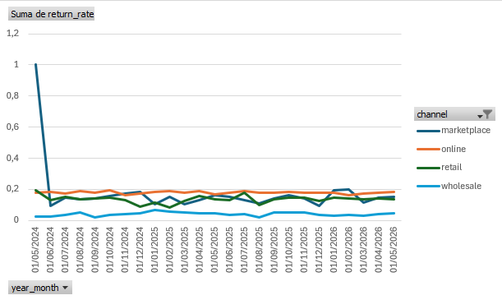
For example, Marketplace has a 100% return rate in May 2024. However, only 3 units were sold and all 3 were returned, so the percentage is highly sensitive to the very small volume. One possible explanation is that Marketplace had only one order at the end of the month and that order was subsequently returned. This is a good example of why return rates should always be interpreted alongside the underlying sales volume.

1.4 Sales waterfall / breakdown
Finally, I created a stacked bar chart showing how gross_sale is broken down into:
- Taxes
- Returned sales value
- Realized net sales
This provides a clear bridge from gross sales to the amount of sales actually retained after taxes and estimated returns. This chart helps distinguish between revenue generated initially and the portion that remains after accounting for taxes and returns.
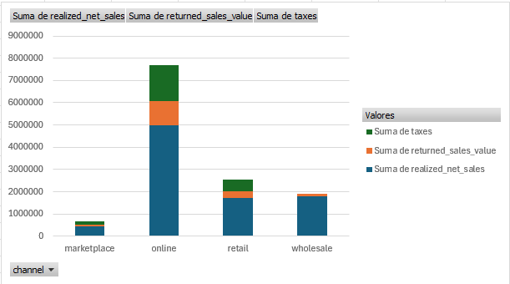

Executive view
The final report for this business question is designed to answer the question differently depending on the audience.
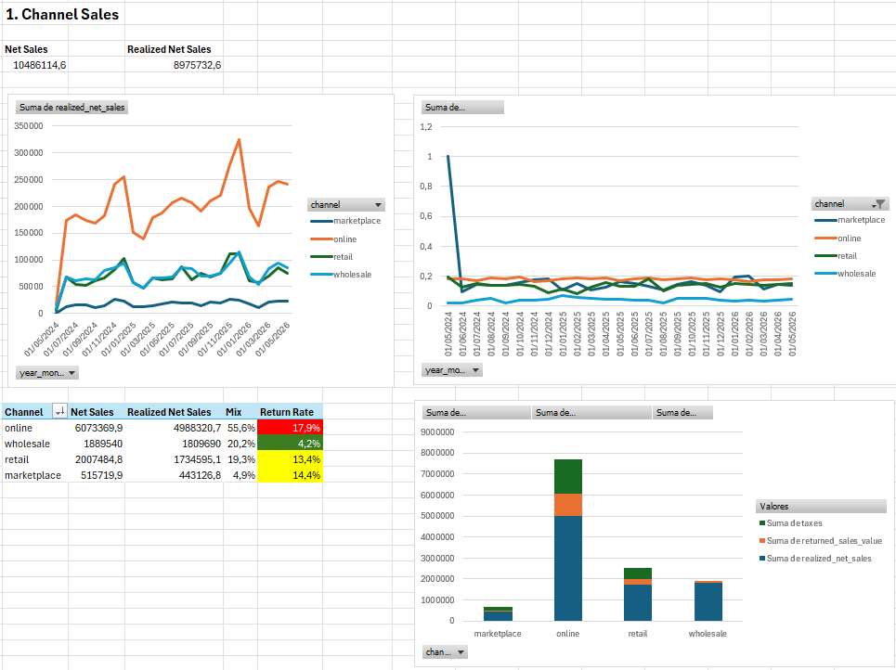
For the CEO, the first things to see are current net_sales versus realized_net_sales, followed by the channel-performance table. The key takeaway is:
Online is the company's primary sales channel, generating 55.6% of realized net sales, but its 17.9% return rate is materially higher than every other channel. Wholesale is much smaller by volume, but its 4.2% return rate means that its realized sales are broadly comparable with Retail.
For the Head of Wholesale, the focus would be on how Wholesale compares with the other channels, particularly the evolution of realized_net_sales and return_rate over time. The key takeaway is:
Wholesale has substantially lower sales volume than Online, but its much lower return rate improves its realized performance, allowing it to surpass Retail in realized net sales.

Net sales and late-arriving returns
For this question, I created two queries in business_questions/report.sql.

2.1 What is wrong with the current model?
The main issue with the current model is that net_sales reflects the value of the sale at the time the sale occurred, but returns can arrive 30–90 days later and update quantity_returned on the original row.
For example, suppose a sale in January has:
- net_sales = €90
- quantity_sold = 3
- quantity_returned = 0
If two units are returned in March, quantity_returned will be updated to 2 on the original January row. However, the original net_sales value will remain €90.
This means that a dashboard based only on the current net_sales field cannot answer "What are the realized net sales of historical transactions, given everything we know today?" It effectively preserves the value calculated at the time of sale and does not reflect returns that arrive afterwards.
The case study explicitly highlights this problem: a dashboard can look correct when first built and then become misleading as new returns are applied to historical sales.

2.2 The solution
Instead of building the dashboard exclusively on the existing net_sales field, I introduced a second metric: net sales as-of report date, which is equivalent to the realized_net_sales metric introduced in Question 1.
This gives us two complementary metrics:
Net sales as-of sale date — net_sales_at_sale
This represents the net sales generated by the transaction at the time of sale, before any future returns are known.
net_sales_at_sale = gross_sale - taxes
This metric is stable and does not change when returns arrive. It is therefore useful when we want to preserve the original value of sales and avoid retroactively changing historical periods.
Net sales as-of report date — realized_net_sales
This represents the value of historical sales that remains after accounting for returns known at the time of the report.
realized_net_sales = net_sales - value_of_returns_known_as_of_report_date
This metric changes over time as additional returns are recorded against historical sales.
An important caveat is that the current source model cannot reconstruct what realized net sales looked like at an earlier reporting date. The dataset only stores the current value of quantity_returned on the original sale row; it does not contain a return date or historical versions of quantity_returned. (This problem will be tackled in section 2.3 Another solution)
Therefore, if a January sale has two returns by March, we can calculate its realized net sales as of March, but we cannot determine from the current source whether those returns had already occurred in February.

Using the output of query 2A, I created a line chart showing both metrics over time, with the ability to filter by channel.
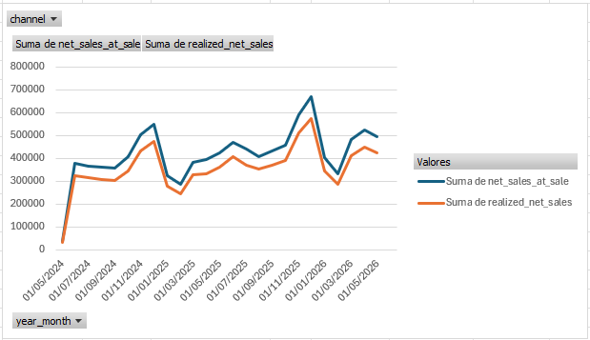
The two metrics answer different questions:
net_sales_at_sale — What sales value was generated when the transactions occurred?
realized_net_sales — Given everything we know as of the reporting date, how much of those historical sales remains after returns?
Immediately after a sale occurs, the two metrics will generally be equal because no future returns are known yet. As returns arrive, realized_net_sales can decrease for the affected historical months, while net_sales_at_sale remains unchanged.
This means the chart remains useful over time: the original sales trend stays stable, while the realized-sales trend progressively incorporates the returns that have become known.

2.3 Another solution — Model sales and returns as separate events
A more robust solution would be to separate sales events from return events, allowing us to preserve the history of when returns occurred.
I would model this using two fact tables:
fct_sale_order_line
Column | Description
sale_line_id | Unique identifier for the sale line
created_at | Timestamp of the original sale
channel | Sales channel
sku | Product SKU
shipment_id | Associated shipment
quantity_sold | Units originally sold
gross_sale | Gross sales value
taxes | Sales taxes
net_sales | Net sales at the time of sale

One row per original sale line. The sale itself should remain immutable, with no mutable quantity_returned field.
fct_return
One row per return event, or per returned sale line if multiple units are returned together.
Column | Description
return_id | Unique identifier for the return event
sale_line_id | Reference to the original sale line
return_date | Date/time the return occurred
quantity_returned | Number of units returned

This model preserves the event history instead of overwriting the original sale record.
It would then be possible to calculate realized net sales as of any historical reporting date by including only returns where return_date <= report_date (query 2B, it is a proposed model, doesn’t run!).
This solves the main limitation of the current source model and allows historical reports to remain reproducible. A report run today and a report run three months from now can both accurately represent what was known at their respective reporting dates.

Contribution margin
For this question, I created two queries in business_questions/contribution_margin.sql.

